**Lab 5: CPU Scheduling - I**

1. **First Come First Serve (FCFS)**

#include<stdio.h>

int main() {

    int n, i, j, arrival_time[20], burst_time[20], waiting_time[20], turnaround_time[20], total_waiting_time = 0, total_turnaround_time = 0;

    float average_waiting_time, average_turnaround_time;

    printf("Enter the number of processes: ");

    scanf("%d", &n);

**// Loop to input the arrival time and burst time for each process**

    for (i = 0; i < n; i++) {

        printf("Enter Arrival time for process P%d : ", i + 1);

        scanf("%d", &arrival_time[i]);

        printf("Enter Burst time for process P%d : ", i + 1);

        scanf("%d", &burst_time[i]);

    }

**// Calculating Waiting time and Turnaround time for each process**

    waiting_time[0] = 0;

    for(i = 1; i < n; i++) {

        waiting_time[i] = 0;

        for(j = 0; j < i; j++) {

            waiting_time[i] += burst_time[j];

        }

        waiting_time[i] -= arrival_time[i];

    }

    for(i = 0; i < n; i++) {

        turnaround_time[i] = burst_time[i] + waiting_time[i];

    }

**// Calculating Total Waiting time and Total Turnaround time**

    for(i = 0; i < n; i++) {

        total_waiting_time += waiting_time[i];

        total_turnaround_time += turnaround_time[i];

    }

**// Calculating Average Waiting time and Average Turnaround time**

    average_waiting_time = (float)total_waiting_time / n;

    average_turnaround_time = (float)total_turnaround_time / n;

**// Printing the Results**

    printf("\nProcess\t Arrival Time\t Burst Time\t Waiting Time\t Turnaround Time\n");

    for(i = 0; i < n; i++) {

        printf("P%d\t\t %d\t\t %d\t\t %d\t\t %d\n", i+1, arrival_time[i], burst_time[i],

waiting_time[i], turnaround_time[i]);

    }

    printf("\nAverage waiting time: %.2f\n", average_waiting_time);

    printf("Average turnaround time: %.2f\n", average_turnaround_time);

    return 0;

}

* **Output**

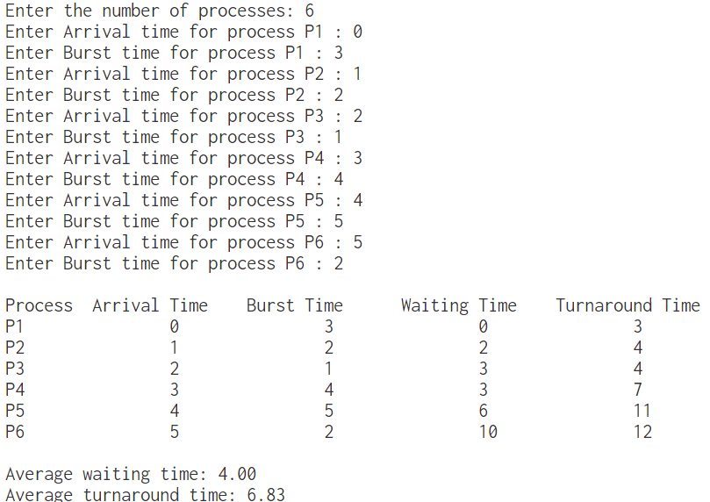

1. **Shortest Job First**

#include <stdio.h>

int main() {

    int n, i, j, temp;

    float total_waiting_time = 0, total_turnaround_time = 0, average_waiting_time,

average_turnaround_time;

    printf("Enter the number of processes: ");

    scanf("%d", &n);

    int arrival_time[n], burst_time[n], waiting_time[n], turnaround_time[n], process[n];

**// Loop to input the arrival time and burst time for each process**

    for (i = 0; i < n; i++) {

        printf("Enter Arrival time for process P%d : ", i + 1);

        scanf("%d", &arrival_time[i]);

        printf("Enter Burst time for process P%d : ", i + 1);

        scanf("%d", &burst_time[i]);

        process[i] = i+1;

    }

**// Sorting processes by arrival time and burst time using selection sort**

    for(i = 0; i < n-1; i++) {

        for(j = i+1; j < n; j++) {

            if(arrival_time[i] > arrival_time[j] || (arrival_time[i] == arrival_time[j]

&& burst_time[i] > burst_time[j])) {

                temp = arrival_time[i];

                arrival_time[i] = arrival_time[j];

                arrival_time[j] = temp;

                temp = burst_time[i];

                burst_time[i] = burst_time[j];

                burst_time[j] = temp;

                temp = process[i];

                process[i] = process[j];

                process[j] = temp;

            }

        }

    }

**// Calculating waiting time and turnaround time**

    int current_time = 0;

    for(i = 0; i < n; i++) {

        if(current_time < arrival_time[i]) {

            current_time = arrival_time[i];

        }

        waiting_time[i] = current_time - arrival_time[i];

        current_time += burst_time[i];

        turnaround_time[i] = current_time - arrival_time[i];

    }

**// Calculating total waiting time and total turnaround time**

    for(i = 0; i < n; i++) {

        total_waiting_time += waiting_time[i];

        total_turnaround_time += turnaround_time[i];

    }

**// Calculating average waiting time and average turnaround time**

    average_waiting_time = total_waiting_time / n;

    average_turnaround_time = total_turnaround_time / n;

**// Printing results**

    printf("Process\tArrival Time\tBurst Time\tWaiting Time\tTurnaround Time\n");

    for(i = 0; i < n; i++) {

        printf("%d\t%d\t\t%d\t\t%d\t\t%d\n", process[i], arrival_time[i], burst_time[i],

waiting_time[i], turnaround_time[i]);

    }

    printf("Average waiting time: %f\n", average_waiting_time);

    printf("Average turnaround time: %f\n", average_turnaround_time);

    return 0;

}

* **Output**

